ProArt StudioBook X: The Desktop Replacement You Never Know You Needed

Most creative work involves a lot of brainstorming-- from the benign illustrative arts to the most complex 3-Dimensional modelling and texturing. After conceptualizing, here comes the creation process itself, where the hardware comes in.

ASUS ProArt StudioBook X brings with it serious hardware for serious work. Boasting a server-class processor with its Intel Xeon E-2776M with a 12-core processor package that leaves your worries out the window. Alongside it is a whopping 64GB ECC RAM, and a SSD Disk drive, you will be sure to carry your work around with you, in its full glory.

At a Glance:

Model | ASUS ProArt StudioBook X
Operating System | Windows 10 Pro
Processor | Intel® Xeon® E-2276M 2.8GHz hexa-core with Turbo Boost (up to 4.7GHz) and 12MB cache
Graphics | NVIDIA Quadro RTX 5000,16GB GDDR6 VRAM
RAM | Up to 128GB DDR4 2666MHz (SO-DIMM x 4, supports ECC) (Reviewed at 64 GB configuration)
Storage | - 1 TB M.2 SSD
Display | 17” LED-backlit WUXGA (1920 x 1200) NanoEdge display  16:10 aspect ratio  Anti-glare panel  3.8mm-thin bezel with 92% screen-to-body ratio  178° wide-view technology  97% DCI-P3 color gamut, 8-bit color  Delta-E < 1.5 color accuracy, PANTONE® Validated
Ports | - 2 x Thunderbolt™ 3 USB-C™ with Display Port 1.4 (up to 40Gbps)  - 3 x USB 3.1 Gen 2 Type-A (up to 10Gbps)  - 1 x HDMI 2.0  - 1 x SD 4.0 / UHS-II card reader (312MB/s)  - 1 x Audio combo jack  - 1 x RJ45 LAN jack  - 1 x Kensington lock  - 1x DC-in
Input | - Keyboard  - Full-size backlit keyboard with 2.0mm key travel and privacy hotkeys, 19mm full size key pitch, integrated Numeric keypad  - Touchpad  - Fingerprint sensor with Windows Hello support  - ScreenPad™ 2.0
Audio | Sound by Harman Kardon  Smart amplifier  Array microphone with Cortana and Alexa voice-recognition support  Long-travel voice coils for improved low-frequency response
Dimensions | - Height:  - 2.82cm (1.11 inches)  - Width:  - 38.2cm (15.03 inches)  - Depth:  - 26.5cm (10.43 inches)  - Weight:  - 2.5kg (5.5 pounds)
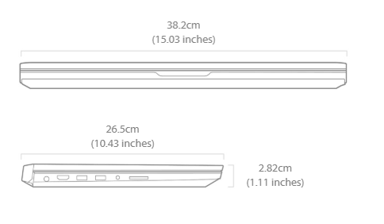

Build

The ASUS ProArt StudioBook is massive. With a body that is 2.82cm thick, the thick plastic feels solid. The screen cover is also thick, and it feels rigid and has little-to-no screen bending.

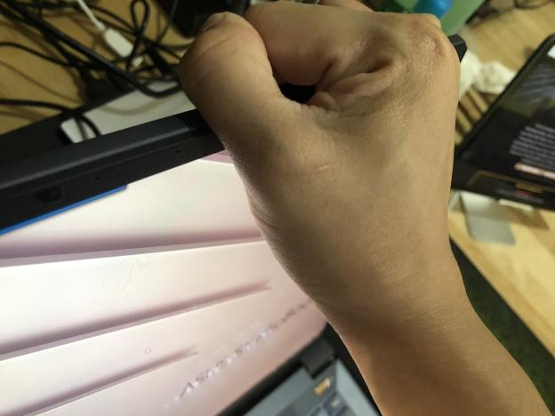

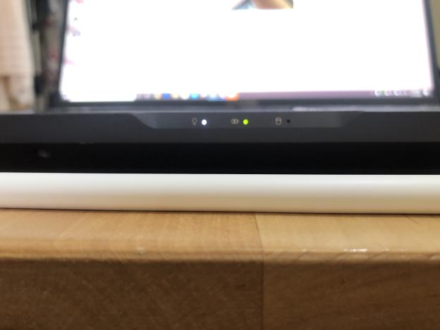
Thickness, with the Apple Pencil for comparison.

The gunmetal finish with gold accents give off a premium, metallic feel that is solid to the touch.

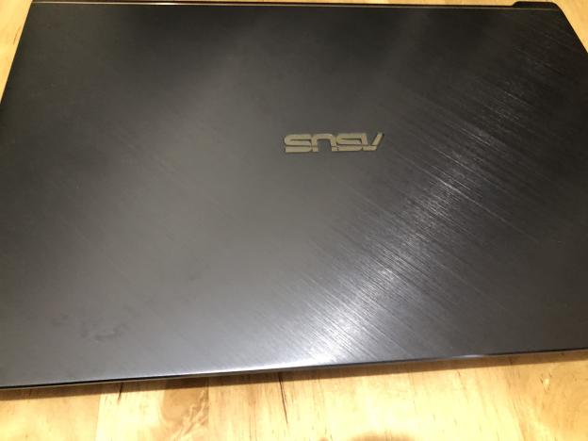

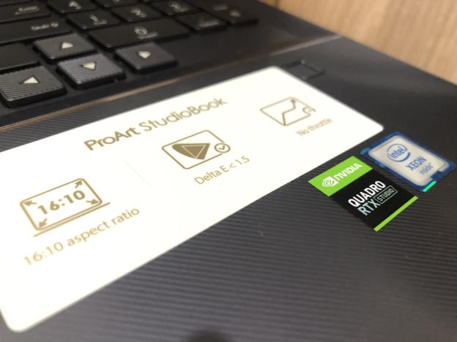

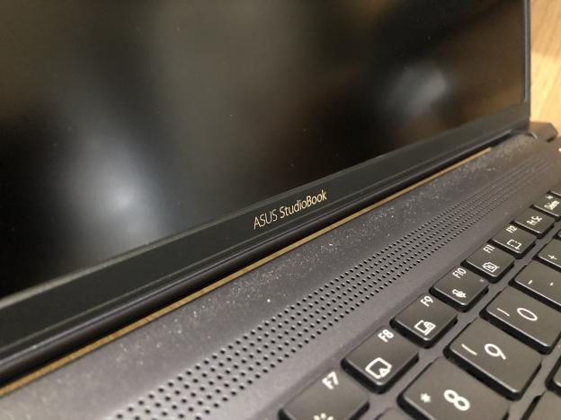

The backlit keyboard gives a subtle light, instantly turning on, and slowly turning off when unused for 30 seconds.

Using a scissor switch, the keyboard itself is fun to use (I am typing this review on the laptop itself). And it sounds nice.

Military Durability?

As far as I know, no reviewer yet has to test the claims to be milspec and endure the cold/high-temp/humidity/shock tests.
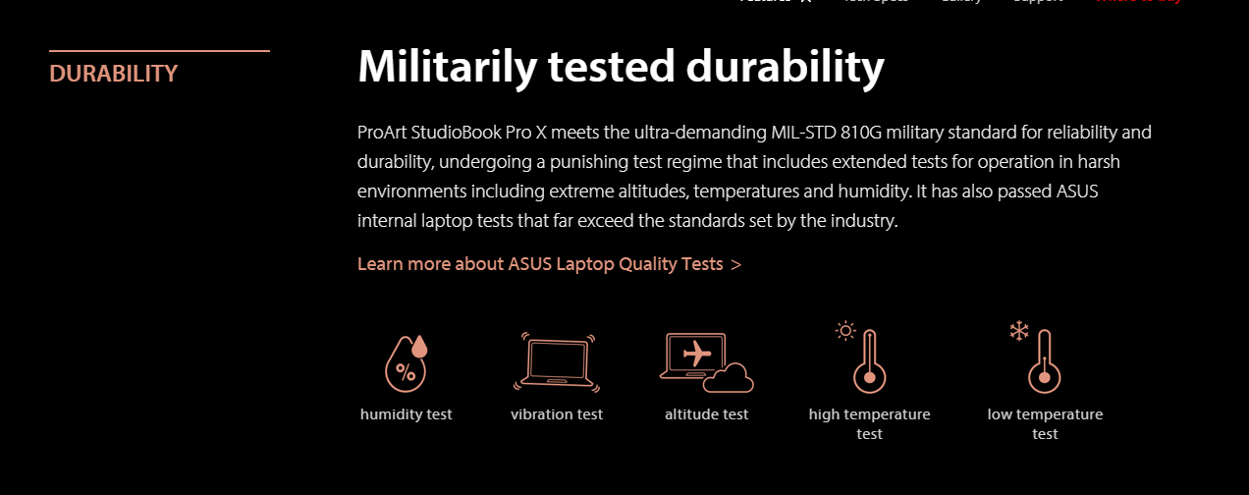
With a laptop this expensive I’d bet no one wanted to try it. :p



How much? We’ll post it at the end.

Gaming Performance Benchmarks
We ran the typical gaming benchmarks on the laptop, and here are the scores:

3D Mark Benchmark: Time Spy
We ran the Time Spy benchmark on the laptop, and here are the results:

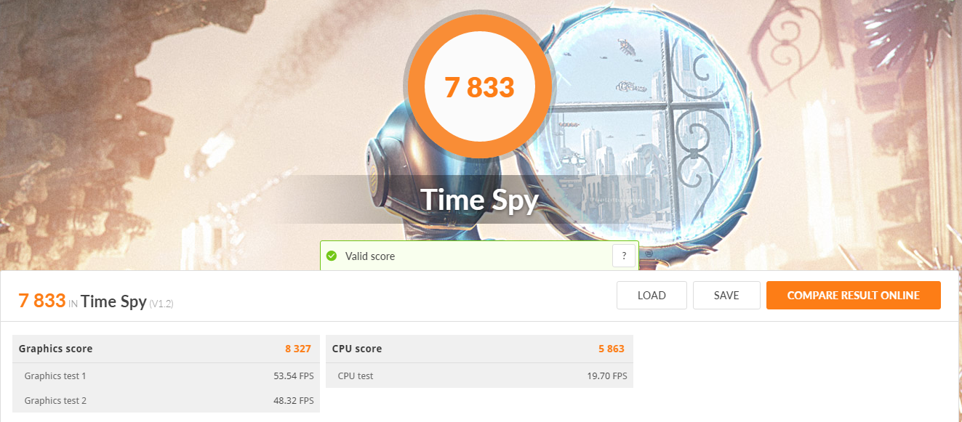

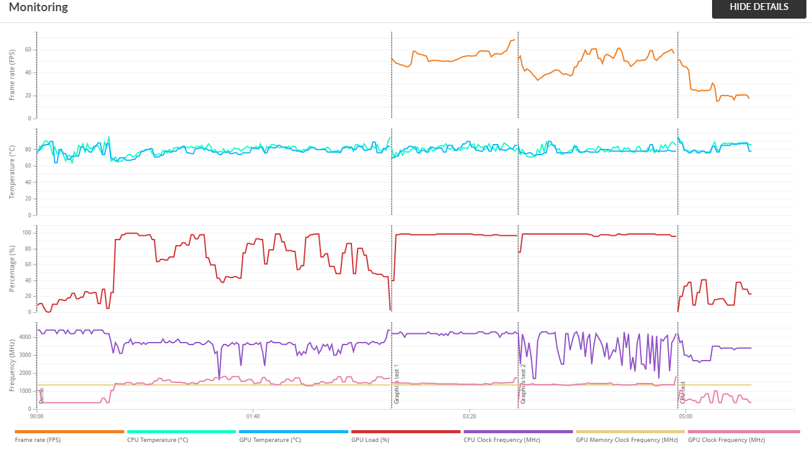

There was screen tearing and some stutter during the CPU-intensive benchmark, where the “tendrils” were being computed. I think the computation for the tendrils work with a Julia-set or with Mandelbrot set-like equations.

3D Mark Benchmark: Port Royal

As the GPU also has Ray Tracing (RT) Cores, we ran the ray tracing benchmark on the laptop.

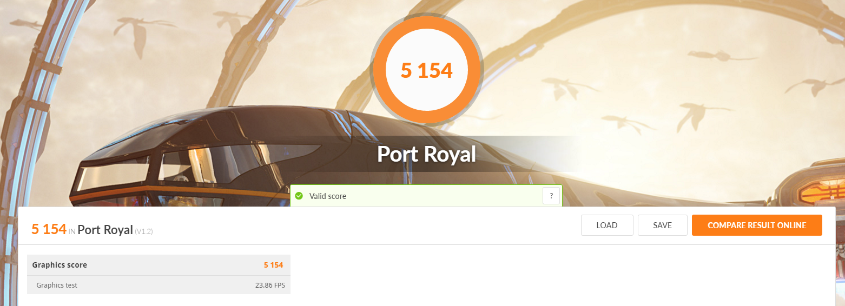

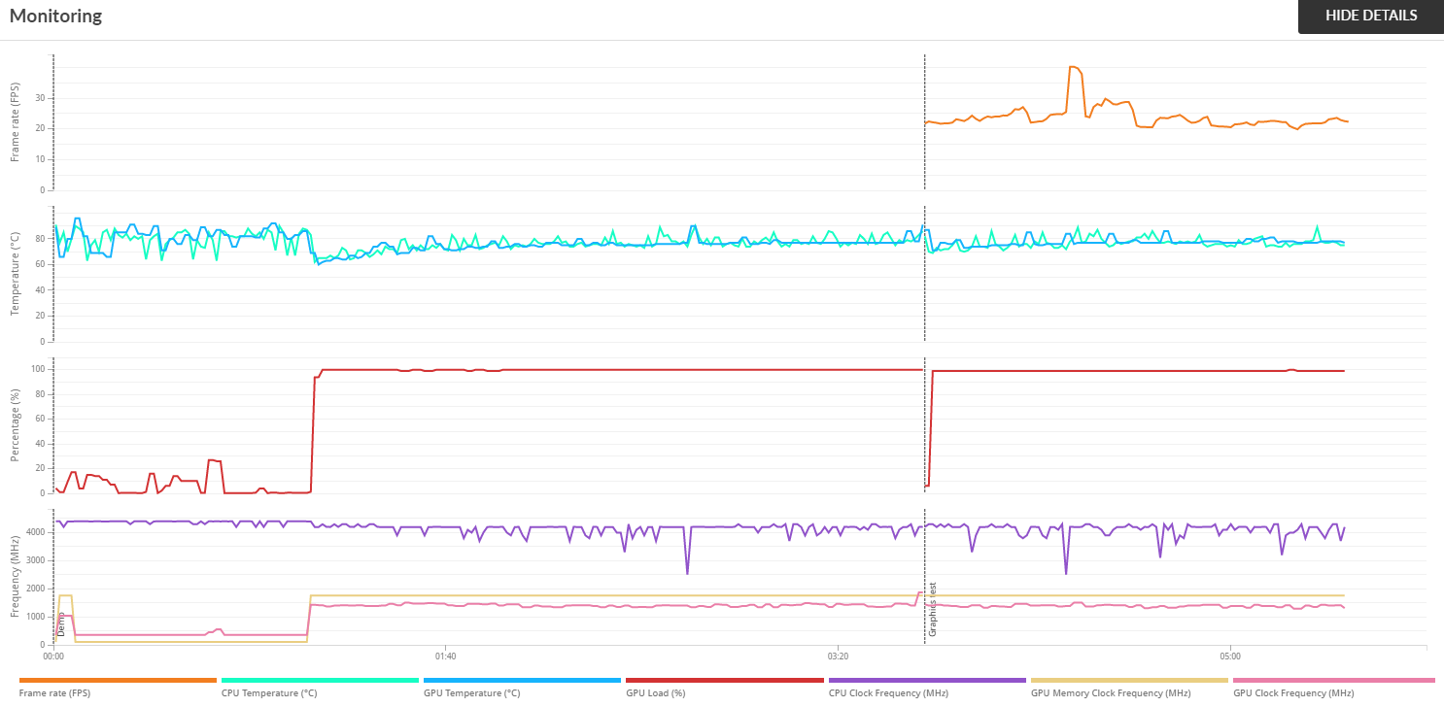

The Takeaway

What this means is that for 3D Artists who wish to work with high-fidelity models and work with 3D modelling & compositing, this laptop will serve you well.

Computational Science: MatLab GPU Bench
SO, with overpowering specs but not *exactly* enough to satisfy the needs of a gaming use case, we need to go over to what exactly is this laptop being marketed at.

One of the markets that this laptop is being marketed at is the computational science part, where it uses a RTX 5000 GPU, with CUDA Cores, RT Cores, and Tensor Cores.
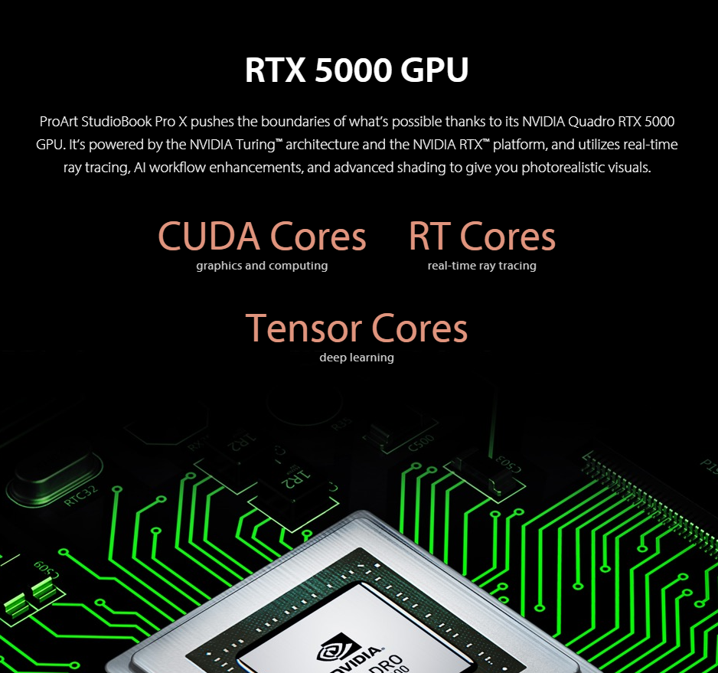
The Tensor Cores are important for A.I. or Machine Learning Research, especially when working with a large dataset.

For this test, we used MatLab in benchmarking the performance, where we offloaded some of the intense computational workflows to the GPU.

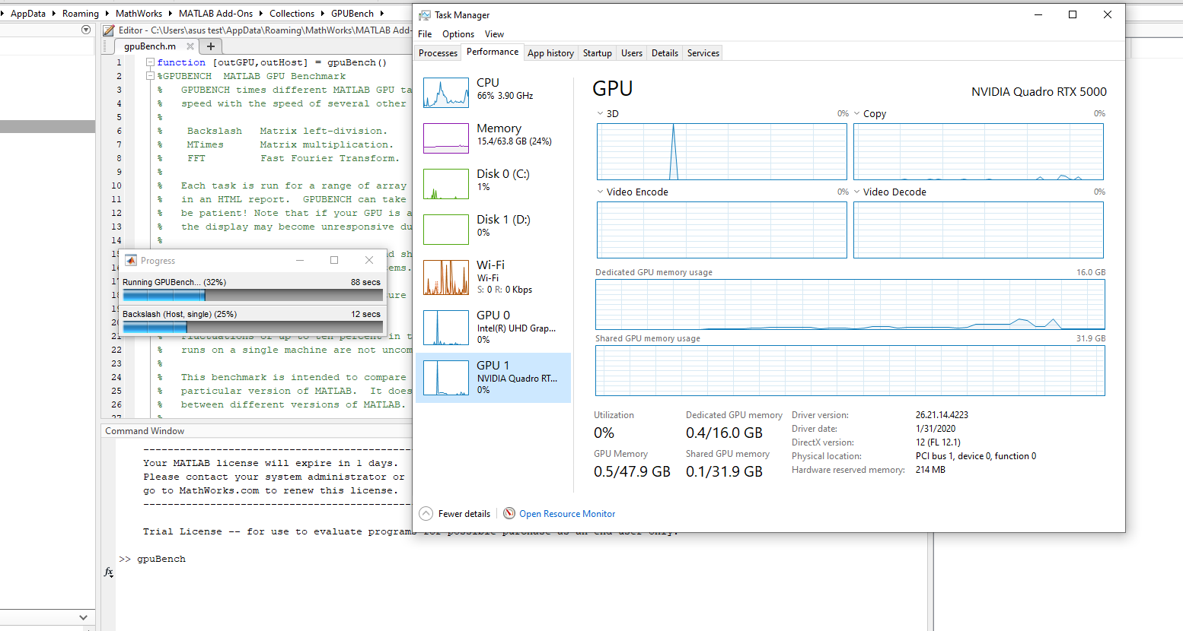

The tests involve Matrix Multiplication (MTimes(double)), Matrix left Division (Backslash(double)), Fast-Fourier Transform of a vector of complex numbers (FFT (double)), MTimes (single), Backslash (single), and FFT (single). More info on the tests in the results per bench.

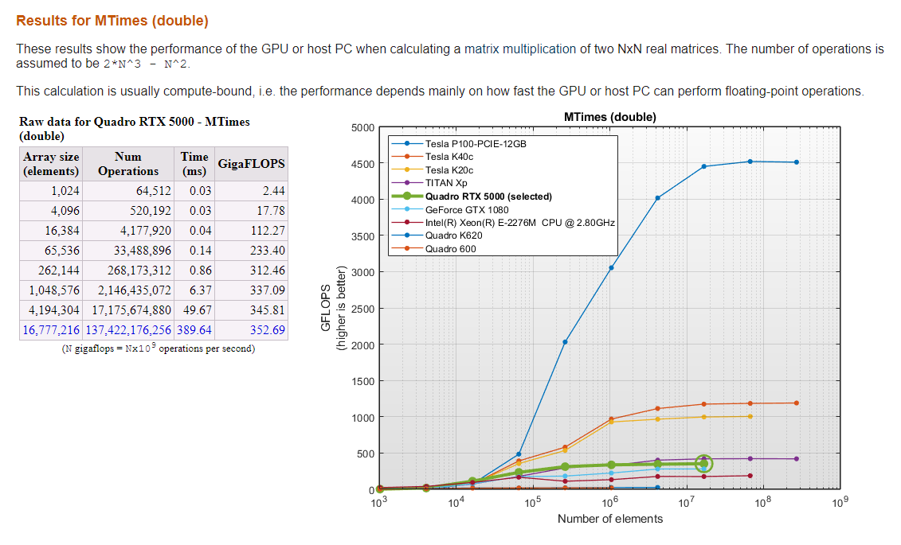
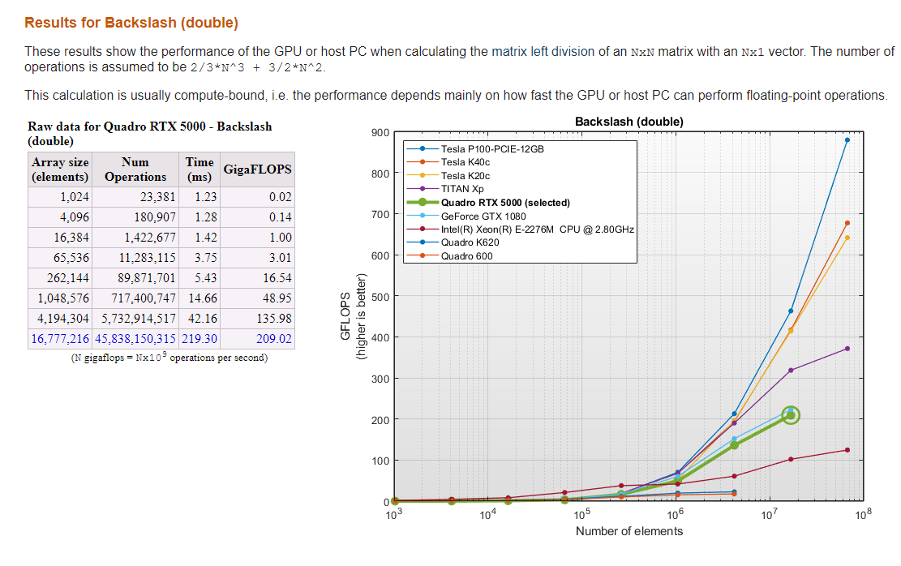
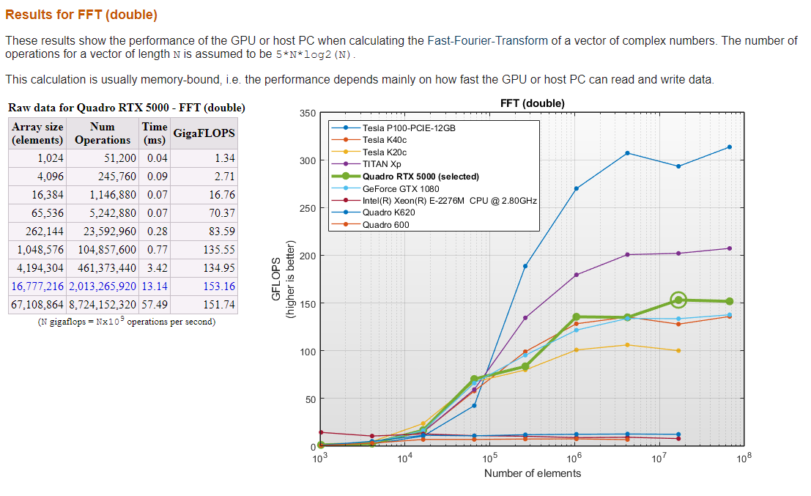
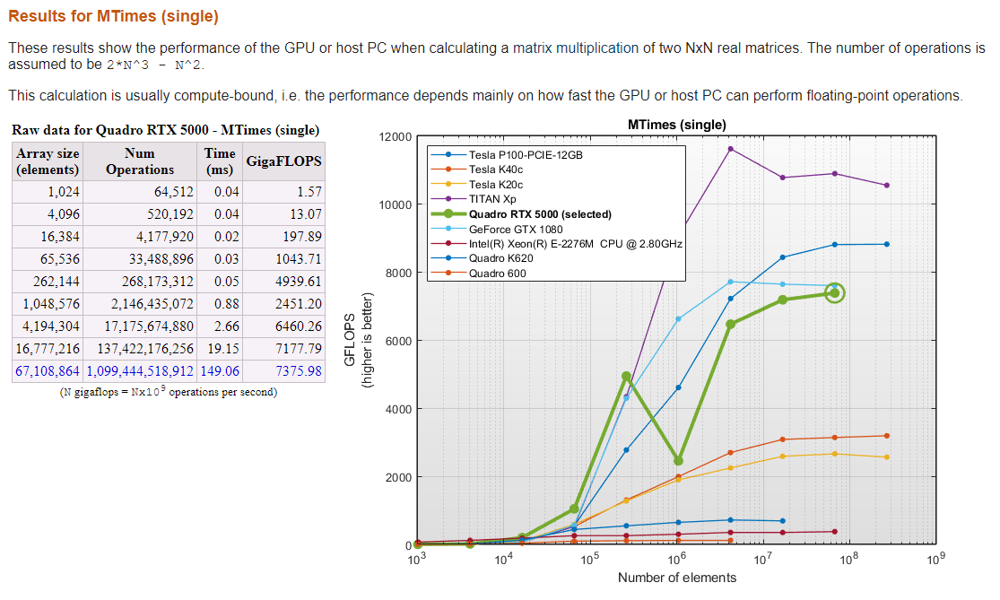
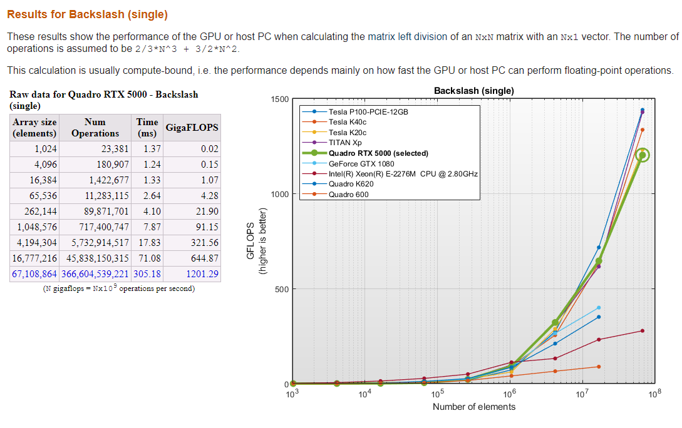
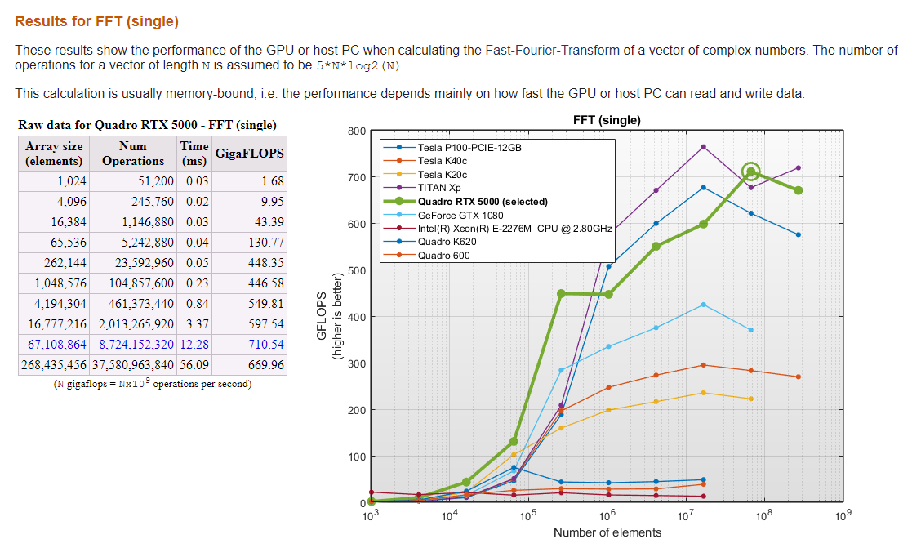

Mandelbrot Set Graphing Simulation

Since we are on the topic of computational benchmarks, we also ran the computational simulation of the mandelbrot set compute and plotting.

Computational significance is also at the same level of the previous GPU Benchmark in Matlab, so this test was more or less done for fun and why the hell not? ^^;

Embed: https://youtu.be/LGXNWNi9ov8

Gaming Benchmarks

The part you’ve been waiting for: the gaming benchmarks! Despite being overly-expensive, and mostly spec’ed for industrial and design work, you will and most likely use it for gaming.

We picked some games where both graphical intensity and computational power is utilized. We went with: The Witcher: WIld Hunt, StarCraft 2, and Stellaris.

StarCraft 2

StarCraft 2 was tested in 1920x1200, Fullscreen Windowed, and on Ultra Settings. This was captured playing a custom arcade map Special Forces Elite 5 - Beta, which I believe is a very demanding map (with a lot of units, events, and scripts).

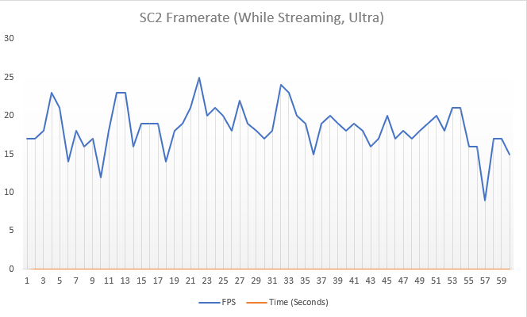

As seen, the computer had some stuttering and lost framerates, but this is considering that you are streaming on ultra settings on a large custom map with multiple models and event scripts.

The Witcher 3: Wild Hunt
Playing the Witcher 3: Wild Hunt on Ultra settings is a blast, and we had almost consistent 60 frames per second.

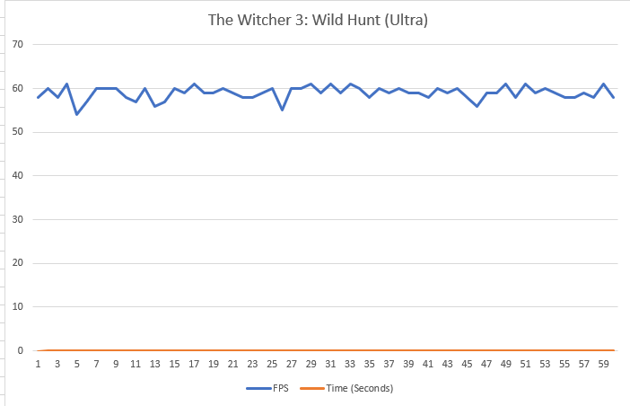

Stellaris

In the final benchmark, we ran the game with a savefile that had a huge galactic map, and loaded at about 3-5 mods that added a lot of scripts to the game.

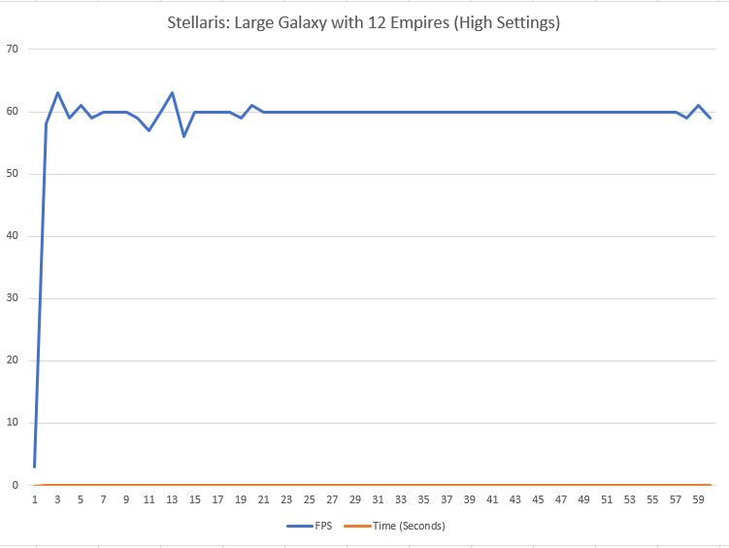

Productivity
We used the laptop as part of our daily driver for the following scenarios:
- Job as a Test Analyst
- Machine Learning daily tasks
- Video Production: Daily Rendering at 4k Apple ProRes HDR

Going through these tasks, we worked on multiple tabs on Chrome, running Adobe Premiere, After Effects, Photoshop, and Audition, running Matlab scripts all at once. The laptop didn’t flinch (in a way) against this kind of workload. The huge 1920x1200 4:3 screen is a huge blessing for multitasking, and the amazing height space is very useful when editing multiple tracks in Adobe Premiere.

The Screen Pad 2.0
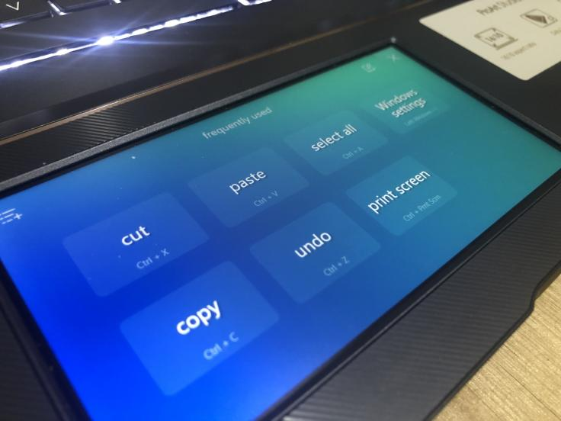

The screen pad was a bit of a godsend especially when working with programs that had a lot of hotkeys, such as Premiere, Photoshop, and After Effects, since most of the hotkeys have three-keys (and sometimes four!). Programming these special functions as a single key on the Screen Pad will make things easier. It was only a problem when we configured the Screen Pad to do a screen capture via SnagIt, there was a delay of at most 2 seconds before the capture was toggled. This was minor, but problematic if you need to capture a screenshot immediately (very important when you need to capture a specific error message that disappears!). Ultimately we had to map it back to the physical Prt Sc button instead.

Some minor annoyances

Truth be told, there were some minor annoyances while using the laptop for both work and gaming.

The second screen at the bottom functions as a literal “second screen”, where you can accidentally drag a window into the bottom screen. This becomes a major impact when playing Real-Time Strategy games where there is a gesture for you to move your viewport by moving your mouse to the edge of the screen.

StarCraft2 has a solution where you can activate the Smart Confine Cursor setting where your cursor is locked to the game screen while in-game, and you can click outside the game screen to other screens while not in-game. This is useful for streamers, since StarCraft 2 is an eSports title afterall.

Command and Conquer: Red Alert 3 had this problem and there is no Confine Cursor setting.

Also, the thickness of the laptop might hurt or injure some users who use the laptop as-is without a dedicated workstation setup, since the thickness might not exactly be ideal for leaning your arm on top due to the sharp bezels and edges of the body.

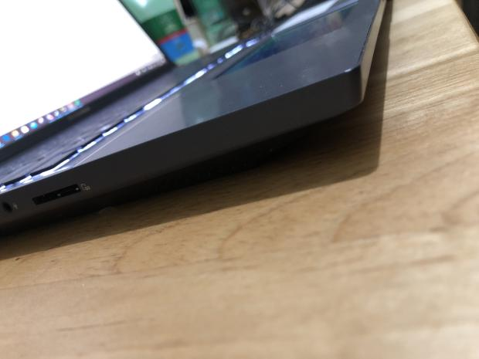
Sharp Bezels

This can be remedied by either 1) using a separate dedicated keyboard for daily use or 2) placing foam on top of the sides.

Overall & Verdict
The ASUS ProArt StudioBook X is a massive device. It can carry your entire work with its fast SSD storage of 1TB, and with the 64GB RAM, 12-core CPU along with the Quadro RTX Studio 5000 GPU, you are assured that you can work without worrying about slowing down for years to come. Your data is also secure and protected from random accidents with its MIL-STD 810G standard. The cost is definitely something to think about: it comes with a hefty Php 299,000 price tag. However, if you’re in the creative industry (game dev or game video creator), software engineering, industrial design, AI engineer, or anything that involves heavy compute power, the return of investment for this laptop is a no-brainer.



